# How to Generate One-Off Test Ouput

You aren’t exporting so much as generating against a target. ☺ So if you wanted to make a PDF, you would have a target for generating PDF using that TOC.

Here’s what I would do: create a new target called test for one off fun! I could do this for you, but, why not learn some cooooool stuff!!!

(If you want me to double check it after, let me know. I have access to the project.)

Here’s how:

Note: You do this ONCE. For everyone. Anyone that opens the project can see this new target when you are done making it. :D

1. Open Project Organizer. Expand the Targets folders. You will create a new Target using a TOC.
2. Right click on Target folder, select Add Target.
3. Source: New from template > Factory Templates > MyTarget is fine. Output, select PDF. Give it a name like… TESTPDFs! Click Add.  
   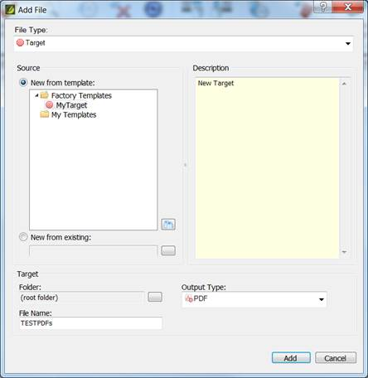
4. A new TESTPDFs (or whatever) target opens. Yay!
5. Click General, time to add some settings!
   1. MASTER TOC: select the TOC you want. Like…Training_CatalogManagement. You can change this anytime, save, and regenerate. :D
   2. Master Page Layout: select default, never change it.
   3. Master stylesheet: select LearnStyles, never change it.
   4. Output Folder: you could browse and choose somewhere local you like or leave to default. If default, it will be in the Output folder in your project location (tfs\stuff\things\blah\mozu_master_thang\output <-made up mostly)  
      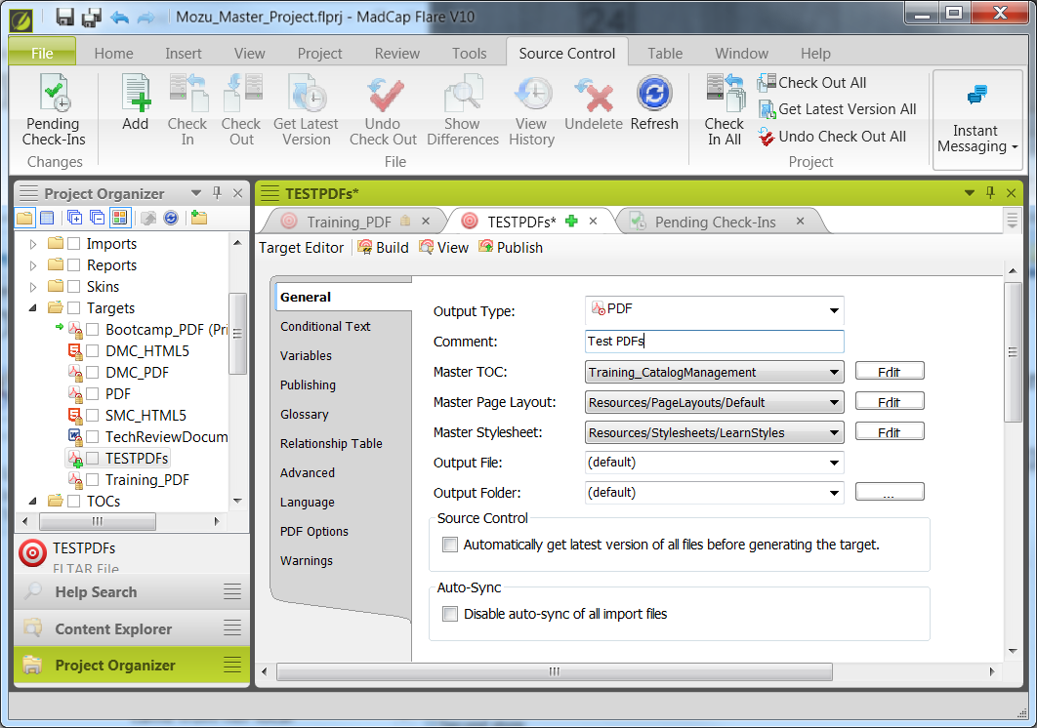
6. Check out the Advanced tab.
   1. You can turn off the Generate TOC procy, Index proc, Glossary proxy if you want.
   2. Expanding Text Effects and Text Popup Effects, select Expand text inline.
   3. In Generated TOC, click Use TOC depth for heading levels.  
      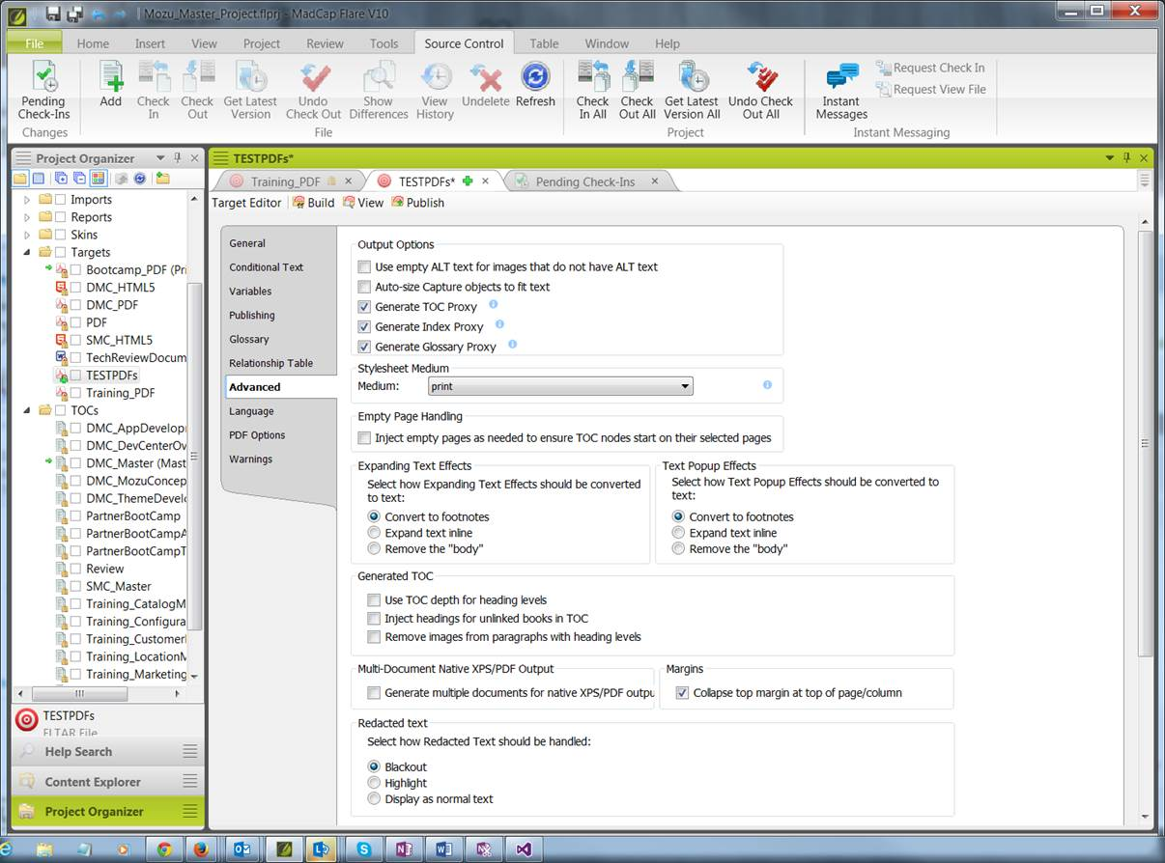
7. SAVE!

Now you can generate some PDF!

1. Click Project tab up top.
2. Click the down arrow for Build Primary.
3. Select Build TESTPDFs.
4. Let the build run, etc. It will then give you the option to open the PDF, etc. DONE.

Want different content?

1. Click on the Project Organizer.
2. Open Target folder > TESTPDFs target.
3. Change the Master TOC.
4. Save.
5. Run your Build again!
6. DONE x2!

Enjoy!